**Background/Theme/General Design:**

* This looks amazing! Exactly what we were looking for

**Homepage:**

● At the bottom we would like to add our PO box as well.

* PO Box 413, Wellington, Ohio

● Fair theme section:

○ Right before the fair book section we would like to add a section for our current fair theme name and design.

○ “2025 Fair Theme: Go Hog Wild”

* Regarding the “join us” at the end of each page - we can remove. All questions have to be filtered through the [loraincountyjuniorfair@gmail.com](mailto:loraincountyjuniorfair@gmail.com). That is contact for our fair coordinator.

Note: The "Join Our Community" CTA section is a placeholder. We recommend including a CTA at the end of each page, such as "Contact Us" or something similar. In addition to the shopping cart, having a general CTA is beneficial. Let us know your preference, and we will update it accordingly.

**History**

● Change How JGB runs to How JFB runs

* We have attached to the google drive lots of photos for Past Board Photos & Royal Court
* Current Officers: (Photos to come)
  + President - Kyleigh Klingshire
  + Vice President - Scott Hook
  + Secretary - Andrew Krupka
  + Treasure - Nolan Norman
  + Executive Member - Kayla Linden
  + Executive Member - Katie Stannard
  + Executive Member - Nate Sword
  + Executive Member - Marshall Ternes
* We can go ahead and remove the timeline, we decided much hasn’t changed over the years to put insufficient information into this. (Remove the button on the top as well.
* Still gathering past officer information

**Fair Entry**

* “Know more” button where does that button go? Is that to Fair Entry Website? If so, could we note that in the description above it, to say “Find direct links to login pages, guideline books, and entry forms at Fair Entry website.

**Forms**

* In the forms menu - Change “Stock the trailer 4h/ffa contest” from to “Stock the Trailer Contest Form”

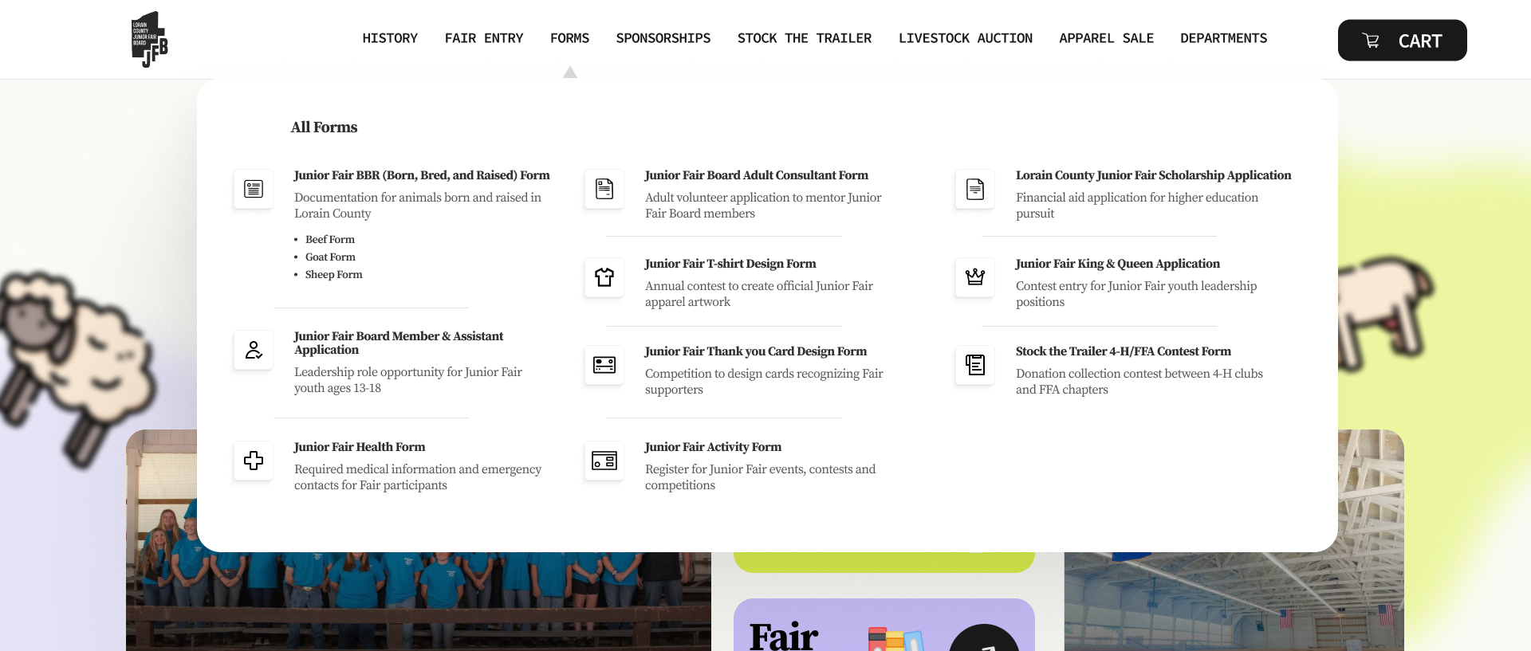

● When they fill out the form could we have a place for attachments as well? BBR forms require proof of purchase receipts. Also that email the send notifications to would be advisor@loraincountyjfb.com

Note: The form shown in the design is a placeholder for the actual form during web development. Yes, it will function properly, sending an email notification once submitted.

**~~Sponsorship~~**

● We love the updated page layout! For the sponsors name list, we would like the image post - it is an image a company puts together for us each year when they donate all our banners we hang around the fair. Just want to publicize their work year round. Also save us time each year from updating the list. (Image in drive)

Note: I have updated the design to match the website's overall style instead of using the original images.

* Sponsorship levels section we are going to remove the 7 platinum day. We are not going to do that one anymore. We tried it out last year and had no takers.
* The sponsorship application section could we have it match the donate section from another page. Just to have it stick out more

**Stock the Trailer**

Note: I have implemented the sections and changes mentioned above. Since I don’t yet have the final text and images, I have temporarily used placeholders until the content is provided.

* We are still working to get all this information together.
* So images have been uploaded to google drive.
* In the donate here section and our donors section - the “donate” and the “zeffy” buttons both take they to zeffy? If so, could we remove the “zeffy” one in our donors since they are right next to each.
* We are going to change the section “Our Food Banks” to a food banks sign up here. So food banks in need can fill out a form and let us know what that are in need of to better support more people.

**Livestock Auction**

* Buyer Picture Examples in the drive.

**Departments:**

* I am working on updating all departments page information in the drive now to make it easier for when you create the rest of the pages.
* Beef page could also add the Beef BBR form there as well, so they don’t have to go looking for it elsewhere as well. Could just copy what the forms page looks like.